Computer Language Coding Concepts

Object Assignment in a Diagram
The principle of object assignment is explained in the article Object Assignment. This article demonstrates the expression of it in a diagram.

About the notation of assignment in general, see the article Assignment in a Diagram.

An assignment is a call to an assignment command, but the expression of an assignment call is given a more basic notation, like this:

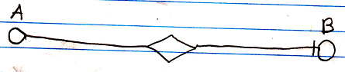

The fact, that the lines are solid, expresses, that it is an object assignment. Other types of assignment get different line types. The access mark indicates the direction. The target object of object reference A is assigned to object reference B.

Object assignment can also be done for commands, but only has the right effect between command definitions, as they make the command definitions the same command definition object.

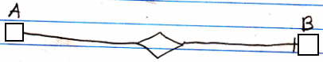

See also: Assignment in a Diagram, Object Assignment

Author & Copyright: Jan-Joost van Zon Date: May 24, 2008 – July 28, 2008 Location: Oosterhout, The Netherlands Status: Finished

